Rate  Sheet | 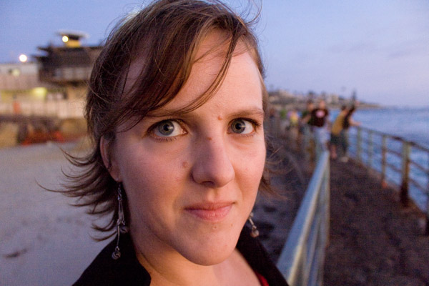

Editing: starts at $30 (see more below)
Mentoring: $45/hour (does not include prep, which when necessary will be charged at the same hourly rate)
Teaching: $18/person, per hour (3-student minimum; does not include prep, which will be charged at $45/hr)

EDITING RATES

PROSE
Includes Fiction, Creative Nonfiction (CNF includes book reviews, craft essays, blogs, too), Academic Essays, and Personal Statements (& other application materials)
Per developmental round: $12-15 per double-spaced page, per round. $50 minimum
Per proofreading round: 4-6 cents per word, per round. $30 minimum
Consults and meetings: $45 per hour

POETRY
Line edits (comments and suggestions—I don’t rewrite)
Single poems (up to 1 page): $20
Groups of poems: $50 per 5 pages
Add $45 for each hour-long follow-up Zoom session.
Collection Edits
(I’ll read deeply, then evaluate the collection with a 1-page letter with an overview of what I see as the collection’s themes, along with suggestions for organization, poems to cut, titles, and sectioning. This option does not include line edits)
Chapbooks (up to 25 pages): $95 flat
Full lengths (up to 75 pages): $175 flat
Add $45 for each follow-up hour-long Zoom session
Intensive Collection Edits
(Add line editing for every poem)
Chapbooks: $250 flat
Full lengths: $350 flat
Add $45 for each follow-up hour-long Zoom session

